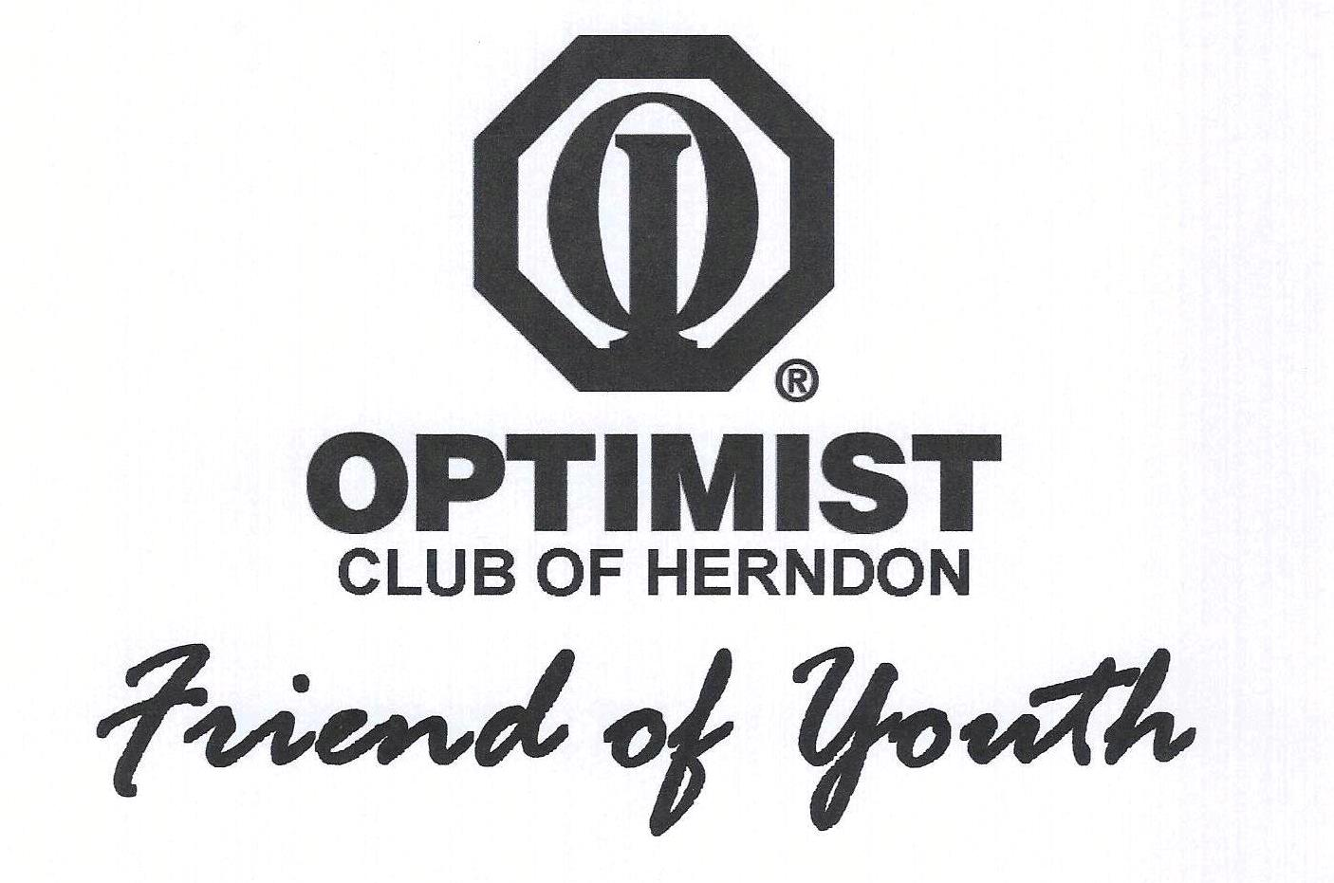

Optimist Club of Herndon, Virginia
College Scholarship Application Instructions

Each year, the Optimist Club of Herndon, Virginia, awards up to three $2000 college scholarships to students who meet the following criteria:

- Participated in Herndon Optimist Club-sponsored program(s)
- Will attend a 2-year or 4-year post-secondary institution

One scholarship, the Jerry Yates Memorial Scholarship, will be awarded to a student graduating from Herndon High School. The other scholarship(s) will be awarded to students graduating from any high school.

Applicants must submit a completed scholarship application, a Letter of Recommendation, and a recent High School Transcript to:

Optimist Club of Herndon, Virginia
Attention: College Scholarship Program
P.O. Box 1771
Herndon, VA 20172-1771

The envelope with the completed application and supporting documentation must be postmarked no later than April 3, 2024. Winners will be contacted no later than May 4, 2024.

Scholarship funds will be distributed directly to the post-secondary institution upon submission to the Optimist Club of Herndon, Virginia, of a tuition bill with the student’s name and institution’s name and payment mailing address.

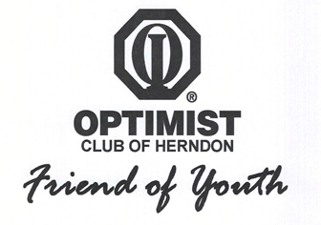
Optimist Club of Herndon, Virginia
2024 College Scholarship Application – Page 1 of 6

Applicant Name

Address

City, State, ZIP
Phone Number

Email Address

Age on
June 1, 2024
High School Graduating From

Applicant: Your signature below attests that all of the information presented in this scholarship application is true to the best of your knowledge.

Applicant Printed Name
Applicant Signature and Date
Parent or Guardian: Your signature below attests that all of the information presented in this scholarship application is true to the best of your knowledge.

Parent or Guardian Printed Name
Parent or Guardian
Phone Number
Parent or Guardian Email Address
Parent or Guardian
Signature and Date

Optimist Club of Herndon, Virginia
2024 College Scholarship Application – Page 2 of 6

Participation in Herndon Optimist Club (HOC)-sponsored programs
HOC program | Years of participation | Specify your role (e.g., player, coach, referee or umpire, team manager, volunteer).
Baseball – Cal Ripken and Buddy-Ball (HRYB)
Basketball – Haley Smith and Buddy Ball (HOYHB)
Basketball – Travel (HOYTB)
Cheerleading (HOYC)

Field Hockey (HRYFH)

Flag Football (HOYFF)

Lacrosse (HRYL)

National Night Out (volunteer activity)
Other (specify*)

*Babe Ruth 13-15 (now 13-16) and 16-18 baseball, Reston-Herndon Little League baseball, Herndon Soccer, and Herndon-Reston Youth Softball are not programs of the Optimist Club of Herndon, Virginia.

Optimist Club of Herndon, Virginia
2024 College Scholarship Application – Page 3 of 6

Participation in high school and (or) other civic activities
that benefit the community
Organization or Program Name | Specific Years Participated | Your role and specific activity that benefited the community (e.g., math tutor for middle school students, leader of food drive)

Optimist Club of Herndon, Virginia
2024 College Scholarship Application – Page 4 of 6

Pick one HOC, high school, or civic activity from those listed above and describe how your involvement positively affected the community (150 words or less).

Optimist Club of Herndon, Virginia
2024 College Scholarship Application – Page 5 of 6

Describe how you personally benefited from involvement in HOC programs (150 words or less).

Optimist Club of Herndon, Virginia
2024 College Scholarship Application – Page 6 of 6

Work experience during high school
Employer | List job position and start and end month/year. | Average hours/week worked

Describe any special circumstances regarding your need for college financial aid.

Reminder: Attach to this application a Letter of Recommendation and a recent High School Transcript.

Please complete all sections in order to be considered.

